Real time water quality monitoring and control system

Literature survey

PREPARED BY,
D.ABIYAVINCY
K.BERLIN
J.JEMILDA
V.S.KERIN SHINU

Survey On: “Real Time Water Quality Monitoring and Control System”

Literature Survey

As real time water quality monitoring are emerging all over the world. From drinking water to industrial waste water. In this general water quality parameters are total Organic carbon, Residual Chlorine, Conductivity, pH, Turbidity. Total three subsystems are used:
• Data Collection Subsystem.
• Data Transmission Subsystem.
• Data Management Subsystem.
Various types of parameters are measured with sensors by placing them into different solutions of water. Data generated is compared with standard values in cloud and if exceeds then message sent from cloud to the users mobile. The given paper presents a detailed information of recent works carried out in smart water quality monitoring. Also, a power efficient, simpler solution for in pipe water quality monitoring based on Internet of Things technology is presented.
The system developed in this paper is generally used for testing water samples and the data uploaded over the Internet are analyzed. The paper presents a detailed survey on the different techniques implemented in existing smart water quality monitoring systems. Also, a low cost, less complex water quality monitoring system is proposed. In this paper we got the idea about how previously water quality is monitored. As 1. Autonomous water quality monitoring using GSM. 2. Using Image Processing technology for water quality monitoring system. 3. Using Zigbee protocol. The proposed system of this paper describes conditions of water quality through various sensors like pH, Water level, Turbidity, Conductivity using WSN through microcontroller and Wi-Fi. From this paper we got the details of each sensor pH, Temperature, Turbidity, Conductivity, Water level etc. How these sensors are working and How they will get interfaced with Arduino controller. how the data generated by sensors will get transferred to the cloud in our proposed system. We studied that the high use of fertilizers and other chemical sectors such as mining and construction have reduced overall quality of water. This paper gives study about Fiji islands water quality which requires frequent data collecting
network for water quality monitoring using IoT and RS(Remote Sensing).the comparative study is provided for different parameters such as pH, Turbidity, Conductivity, Temperature etc.
In this paper, methodologies results are as, when the sensor board is switched on, the sensors are stumble on individual water parameter information. Here represented and we studied about statistics of water stage pH, Turbidity, Temperature etc are displayed on the dashboard of system. This paper also proposes a sensor based water quality monitoring system measuring physical and chemical parameters of water. This paper is beneficial for the development of water quality measuring devices, for measuring and analysis of water used for various living things ex. Human beings, animals as well as marine fishes and plants. It focuses on checking odour, Water level, Turbidity and temperature and verified on a daily basis. Here also Data transmission subsystem include wireless communication device with built in security features that transmits data from controller to data storage. Data Collection subsystem consist of multi-parameter sensors

1. Methodologies of Problem solving
• System Architecture:

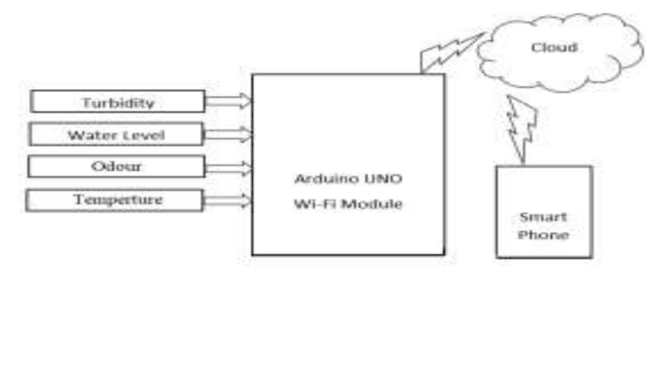

• Decision Tree (Algorithm):

Decision Trees are considered for representing classifiers. A decision tree is a classifier expressed as a recursive partition of the instance space. The decision tree consists of set nodes that form a rooted tree, it is a directed tree with a node called root that has no incoming edges. All other nodes have only one incoming edge. A node with outgoing edges is called an internal or test node. Decision tree generates the rule for the classification of the generated data set. The decision tree generally represents the flow chart like a tree structure that classifies instances by sorting them based on the feature (attribute) value.

Algorithm

1. Take data as a input
2. If the dataset has more features and condition then apply it on data parameters.
3. The data generated from the sensors are evaluated depending upon WHO values.
4. Classify and splitting the data.
5. Analysis of data.
6. Find the accuracy of the model.
7. Compare the value store on cloud.

Advantages

1. Due to automation it will reduce the time to check the parameters.
2. This is economically affordable for comman people:
3. Provides the prevention from diseases caused by water
4. Accuracy in measurement
5. SMS alert is sent to the user

Limitations

1. System hardware need to be handled with care:
As we are using different sensors and arduino controller it is mandatory to handled them with care.
2. Only limited users are added to handle the system:
Only the persons who are authorized to system able to access it.

Application

1. This system is used in commercial and domestic use:
The water for commercial uses come from the surface and under ground sources. The extend to which community uses a surface or underground source depends on which source is more abundunt in the particular area.
2. Water supply agencies:
water supply is the provision of water by public utilities, commercial organisations, community endeavors or by individuals usually via system of pipes.

Conclusion

This presents a detailed survey on the tools and techniques employed in existing smart water quality monitoring systems. Also, a low cost, less complex water quality monitoring system is proposed. The implementation enables sensor to provide online data to consumers. The proposed setup can be improved by incorporating algorithms for anomaly detection in water quality. So this proposed system will surely helpful to the society for safe supply of water.

References

[1] S.Geetha ,S.Gouthami, “Internet of things enabled real time water quality monitoring system.”, DOI
10.1186/s40713-017-0005-y (2017).
[2] Jianhua D, Guoyin W, Huyong Y, Ji X, Xuerui Z “A survey of smart water quality monitoring system.”, Environ
SciPollut Res 22(7):4894906 (2015).
[3] JAYTI BHATT, JIGNESH PATOLIYA “IOT BASED WATER QUALITY MONITORING SYSTEM.”,
ISSN:2347-6982(2016).

